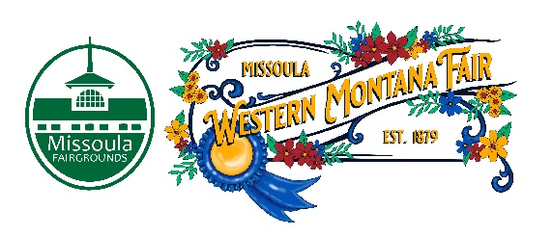

Missoula County Fair Event Committee
Thursday, February 8th, 2024, at 10:00 a.m.
Fair Office, Building #12
Missoula County Fairgrounds
1101 South Avenue West, Missoula, MT 59801
Join on your computer, mobile app or room device.

Committee Members

- Jim Sadler – Chair
- Dave Bell - Vice-Chair
- Sarah Knobel
- Brooke Martin
- Hailey Jo Bergstrom
- Tonya Robert
- Jane Kelly
Meeting Minutes
- Meeting commencement
  - Vice - Chair Dave Bell called the meeting to order at 10:00 a.m. Dave Bell, Tonya Robert, Jane Kelly, Brooke Martin, Sarah Knobel, Billie Brown, Allison Wilson, Jacey Grange, Tenzin Lhaze and Campbell Barret in attendance.
- Rollcall & introductions
- Approval of agenda
  - Agenda has been approved for February.
- Public comment on items not on the agenda
  - None.
- Action Items
  - Approval of minutes from January 11th, 2024
- Discussion Items
- Western Montana Fair
  - Food Vendor Application update
    - There are 12 concession vendor applications with 3 new food vendors. There are 11 applications for commercial vendors. For profit food vendors are charged 20% and non-profit food vendors are charged 17%.
  - RFP updates
    - Preferred alcohol vendor RFP is at the auditors. Interviews are scheduled for March. Compost/Trash/Recycling RFP is at the auditors as well. Both RFPs will be going out at the end of the week/beginning of next week.
  - Plaza entertainment
    - Plaza entertainment scheduling is going well. There is going to be performance/demonstration in the Historic Plaza. There are going to be markets planned in the Floriculture parking lot.
  - Service clubs
    - Allison has been meeting with the service groups we are working with. There are going to be new service positions this year to accommodate the new grandstands and the additional Fair day.
- 4-H update
  - Campbell Barrett reports that Deidad left 4-H and there will be a position advertised for her old role. Current enrollment for 4-H is 412 kids which is 10-15% more from last year. The extension office is really busy at the moment.
- Development update
  - Clouse Bauer Arena
    - Arena is ahead of schedule at this point. Concrete will be poured the week of the 19th. Emily and Billie has been attending neighborhood meetings to talk about the Fairgrounds expansion and the music festival.
- Adjournment
  - Meeting adjourned at 10:30 a.m. Next meeting Thursday, March 14th, 2024 10:00 a.m., at Missoula County Fairgrounds, Fair Office, Building #12, 1101 South Avenue W, Missoula, MT 59801.

